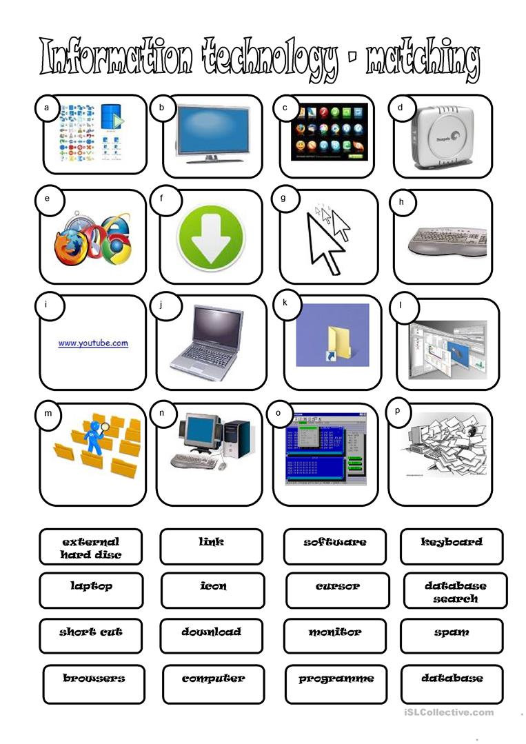

Click inside the Blue Circle and type the letter (inside the circle) that matches the Technology Picture to the Technology Term.