**Type & Match the Computer Parts**

Look at each computer part below. Each part name is listed in the Computer Parts box. Click in the box to the right of each picture and type the part name using a different font for each name. (You pick the font.)

Computer Parts: **Speakers**, **Keyboard, Printer**, **CPU**, **Mouse**, **Monitor**

|  |  |  |  |
| --- | --- | --- | --- |
| C:\Users\Cricket\AppData\Local\Microsoft\Windows\Temporary Internet Files\Content.IE5\KXK7FGXY\MC900431539[1].png | Part Name: | C:\Users\Cricket\AppData\Local\Microsoft\Windows\Temporary Internet Files\Content.IE5\XCMYT49W\MC900360648[1].wmfC:\Users\Cricket\AppData\Local\Microsoft\Windows\Temporary Internet Files\Content.IE5\PU49070N\dglxasset[1].png | PART NAME: |
| C:\Users\Cricket\AppData\Local\Microsoft\Windows\Temporary Internet Files\Content.IE5\MS0NNHJW\MP900399981[1].jpg | **PART NAME:** |  | **PART NAME:** |
| C:\Users\Cricket\AppData\Local\Microsoft\Windows\Temporary Internet Files\Content.IE5\D8YHRHXL\dglxasset[2].png | **PART NAME:** | C:\Users\Cricket\AppData\Local\Microsoft\Windows\Temporary Internet Files\Content.IE5\XCMYT49W\dglxasset[1].png | **PART NAME:** |

Look at the computer part words in the box below. Each word has a colored square next to it that matches a color section in the circle. Drag each matching computer part picture to the matching color on the circle.

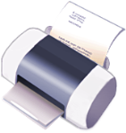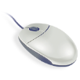C:\Users\Cricket\AppData\Local\Microsoft\Windows\Temporary Internet Files\Content.IE5\XCMYT49W\MC900360648[1].wmf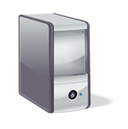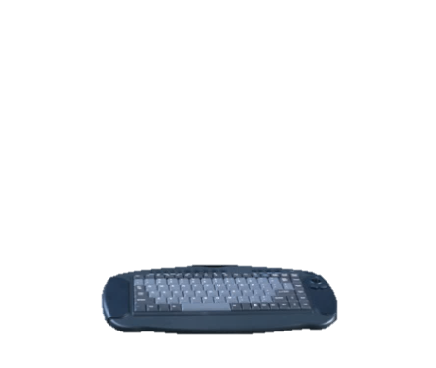

**Align Right**

**Center**

**Align Left**

**Change this line to a Green Font Color Change this line to Candy Cane Font.**

**Change this line to a Blue Font Color Change this line to Chiller Font.**

**Insert the Cloud Shape: Insert a 6-Point Star:**

**Format the following lines:**