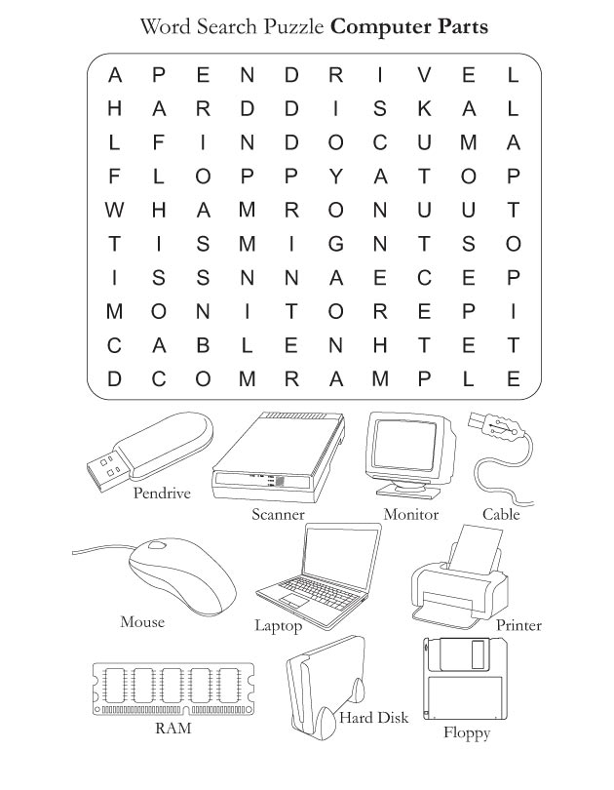

Directions: Click on INSERT, Click on a LINE SHAPE, Drag the LINE across the Computer Part Words in the Puzzle.