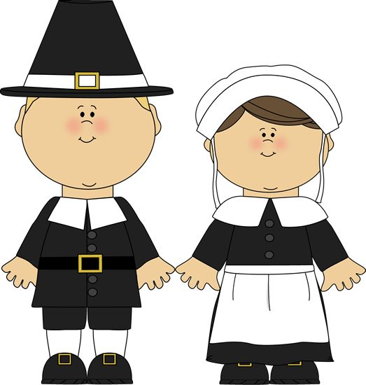I am thankful for:

Name:

**Mrs. Bevill’s Computer Class**

**THINGS**

**PEOPLE**

**PLACES**