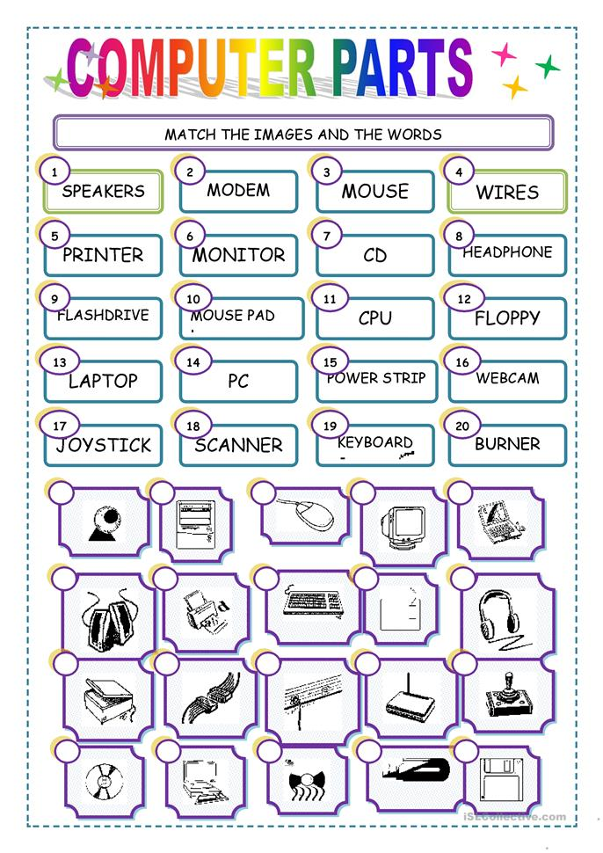

**DRAG AND DROP THE NUMBERED CIRCLES NEXT TO THE CORRECT COMPUTER PART.**