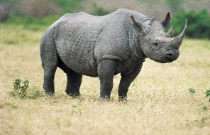
Name(s): ________________________/_________________________
ENDANGERED BLACK RHINOCEROS WEB SEARCH
THE FOLLOWING WEB SITES WILL BE USED TO FIND THE ANSWERS TO THE QUESTIONS.
http://www.worldwildlife.org/species/black-rhino
- Weight
- Location/Place

http://animals.nationalgeographic.com/animals/mammals/black-rhinoceros/
- Diet
- Time of Day the Rhino Eats

http://www.enchantedlearning.com/subjects/mammals/rhino/Rhinoprintout.shtml
- Appearance
- Meaning of Rhinoceros
- Threats/Extinction

http://wwf.panda.org/what_we_do/endangered_species/rhinoceros/african_rhinos/black_rhinoceros/
- Comparison to White Rhino
- Life Cycle
- Population

Directions: Click on one of the Web Sites above (Press the Ctrl key when you click on the Web Site) you need to use to help find the answer for the question. Highlight the Answer and then press Ctrl + C to Copy and then click where you want to put/paste the answer and press Ctrl + V

Questions:

- Why are the Black Rhinos in danger of extinction?

- What is the population of the Black Rhino?

- What is the average weight of the Black Rhino?

- What does the word “rhinoceros” mean?

- Name a place where the Black Rhino lives.

- Is the Black Rhino bigger or smaller than the White Rhino?

- Is the Black Rhino an herbivorous or carnivorous? (Diet)

- How long does a Black Rhino live? (Life Cycle)

- Do Black Rhinos feed during the day or at night?

- Describe the horns of the Black Rhinoceros. (Appearance)

